
Nourish Net: A Smart Food Waste Redistribution and Resource Management Platform
A CAPSTONE PROJECT REPORT
A Capstone Project Report submitted in partial fulfilment of the requirements for the Course of
CSA1013 – Software Engineering
to the award of the degree of
BACHELOR OF ENGINEERING / BACHELOR OF TECHNOLOGY
IN
COMPUTER SCIENCE AND ENGINEERING
Submitted by
S. Spandana (192525160)
Under the Supervision of
Dr. Latha
SIMATS ENGINEERING
Saveetha Institute of Medical and Technical Sciences
Chennai-602105
SEPTEMBER 2026

SIMATS ENGINEERING
Saveetha Institute of Medical and Technical Sciences
Chennai-602105
BONAFIDE CERTIFICATE
This is to certify that the Capstone Project entitled “Nourish Net: A Smart Food Waste Redistribution and Resource Management Platform” has been carried out by S. Spandana (Reg. No: 192525160) under the supervision of Dr./Prof. Latha and is submitted in partial fulfilment of the requirements for the current semester of the B.Tech Computer Science and Engineering program at Saveetha Institute of Medical and Technical Sciences, Chennai.

COURSE COORDINATOR | COURSE FACULTY
Dr. K Anitha Davamani Dr. Latha
Associate Professor Assistant Professor
Nxt-Gen Computing Department Name
SIMATS Engineering SIMATS Engineering
SIMATS, Chennai-602105 SIMATS, Chennai-602105

SIMATS ENGINEERING
Saveetha Institute of Medical and Technical Sciences
Chennai-602105
DECLARATION
We, S. Spandana, of the Department of Computer Science and Engineering, SIMATS Engineering, Saveetha Institute of Medical and Technical Sciences, Chennai, hereby declare that the Capstone Project Work entitled “Nourish Net: A Smart Food Waste Redistribution and Resource Management Platform” is the result of our own bonafide efforts. To the best of our knowledge, the work presented herein is original, accurate, and has been carried out in accordance with the principles of engineering ethics and academic integrity. All sources, references, data, and other materials used in the project have been appropriately acknowledged. We further declare that the data, results, analysis, and findings presented in this report have not been fabricated, falsified, or manipulated. Any external tools, software, datasets, computational resources, or AI-assisted tools used during the project have been appropriately disclosed. We confirm that all applicable ethical, academic, institutional, and professional requirements have been duly followed throughout the planning, execution, analysis, and documentation of the project.
Place: Chennai
Date:

Signature of the Students with Names
S. Spandana (192525160)

SIMATS ENGINEERING
Chennai-602105
Individual Contribution Statement
(Mandatory for all team projects)
Student Name / Reg. No. | Specific Responsibilities | Design & Development | Testing & Analysis | Report Contribution | Approx. %
S. Spandana  (192525160) | Backend architecture, matching engine logic, database design | Backend & matching engine implementation | Unit testing of matching algorithm, performance testing | Ch. 3 (Design), Ch. 4 (4.1-4.3) | 50%
S. Spandana (192525160) | Frontend apps, notification & tracking service, requirements analysis | Donor/recipient app UI, notification module | Usability testing, pilot data collection & analysis | Ch. 1, Ch. 2, Ch. 4 (4.4-4.8), Ch. 5 | 50%
Total |  |  |  |  | 100%

ABSTRACT
Food wastage at the household, restaurant, and event level continues to grow alongside food insecurity among vulnerable urban populations, creating an engineering problem of matching perishable, time-critical surplus supply with fragmented, geographically dispersed demand. Existing donation channels rely largely on manual phone calls and informal WhatsApp groups, which do not scale, provide no safety validation, and result in significant surplus food being discarded before it reaches a recipient. This project addresses the need for a structured, technology-enabled platform that can discover surplus food in real time, verify its safety for redistribution, match it to the nearest eligible recipient organisation, and coordinate last-mile pickup and delivery within a narrow time window.
NourishNet is proposed as a smart food waste redistribution and resource management platform comprising a donor-facing mobile/web application, a recipient (NGO/shelter) application, a volunteer logistics application, and a backend service layer built around a perishability-aware matching engine, a food safety and quality validation module, and a route and pickup scheduling module. The system was designed using a requirements-driven, trade-off-based engineering methodology: stakeholder and functional/non-functional requirements were captured, three candidate architectural alternatives were evaluated against a weighted decision matrix (performance, cost, safety, sustainability, reliability), and the selected three-tier microservice-oriented architecture was implemented using a REST API gateway, a relational database for transactional data, and a geo-indexed cache for live availability lookups.
The prototype was implemented and subjected to a six-week pilot with simulated and partner-provided donation data. Results show the weekly volume of surplus listings grew from 42 to 104 items while the match success rate — the proportion of listed surplus successfully redistributed before expiry — improved from approximately 71% to 91% as the matching engine's ranking logic and the recipient network matured. Test-plan verification confirmed that 90% of functional requirements and all critical food-safety constraints were met. The principal conclusion is that a perishability-aware, rule-validated matching architecture can materially increase the proportion of surplus food redistributed within a viable time window compared to manual coordination, while surfacing measurable sustainability and social-impact metrics for institutional reporting.
Keywords: food waste redistribution, surplus food matching, perishability-aware scheduling, resource management platform, food security, sustainable logistics

TABLE OF CONTENTS
Sl. No | Title | Page No.
i | Certificate from the Supervisor | ii
ii | Declaration by the Candidate | iii
iii | Individual Contribution Statement | iv
iv | Abstract | v
v | List of Figures | vi
vi | List of Tables | vii
vii | List of Abbreviations | viii
1 | CHAPTER 1: Introduction and Engineering Problem | 1
2 | CHAPTER 2: Literature Review and Existing Solutions | 5
3 | CHAPTER 3: Engineering Design & Trade-offs, Sustainability, Ethics, Safety, Risk & Security | 9
4 | CHAPTER 4: Implementation, Testing & Results, Project Management | 17
5 | CHAPTER 5: Conclusion, Future Work and Reflection | 24
 | References | 27
 | Appendices | 28
Note: Page numbers are indicative; update automatically in Word via References > Update Table, or renumber manually once the document is finalised.

LIST OF FIGURES
Figure No. | Figure Name | Page No.
3.1 | NourishNet System Architecture | 12
4.1 | Donation-to-Redistribution Process Flow | 18
4.2 | Project Timeline (Gantt Chart) | 22
4.3 | Pilot Results – Weekly Listings, Redistribution and Match Success Rate | 20

LIST OF TABLES
Table No. | Table Name | Page No.
2.1 | Comparative Analysis of Existing Approaches | 6
3.1 | Stakeholder / User Requirements | 9
3.2 | Functional & Non-Functional Requirements | 10
3.3 | Constraints & Applicable Standards | 11
3.4 | Design Specifications | 11
3.5 | Alternative Solution Evaluation Matrix | 13
3.6 | Trade-off Analysis | 14
3.7 | Sustainability, Ethics, Safety, Security Evaluation | 15
3.8 | Risk Register | 16
4.1 | Tools / Software Used | 18
4.2 | Test Plan & Verification | 19
4.3 | Requirement Achievement Summary | 21
4.4 | Roles & Contribution | 23
4.5 | Budget Estimate | 23

LIST OF ABBREVIATIONS / SYMBOLS
Symbol | Description | Unit
NGO | Non-Governmental Organisation | —
API | Application Programming Interface | —
UI/UX | User Interface / User Experience | —
DB | Database | —
REST | Representational State Transfer | —
ETA | Estimated Time of Arrival | min
SLA | Service Level Agreement | —
GPS | Global Positioning System | —
FSSAI | Food Safety and Standards Authority of India | —
IEEE | Institute of Electrical and Electronics Engineers | —
CRUD | Create, Read, Update, Delete | —
kg | Kilogram | kg

CHAPTER 1
INTRODUCTION AND ENGINEERING PROBLEM

1.1 Background
Urban food systems generate substantial surplus at every stage of the supply chain — restaurants over-prepare for uncertain footfall, event caterers discard prepared food after functions, retail outlets clear near-expiry stock, and households routinely over-purchase perishables. At the same time, community kitchens, shelters, and NGOs operate with constrained budgets and frequently cannot meet daily meal demand. The technical challenge is not a shortage of food but a coordination failure: surplus and need are separated in time, location, and information, and existing coordination channels (phone calls, informal messaging groups, manual spreadsheets) cannot handle the volume, time-sensitivity, or safety verification that redistribution requires.
NourishNet is conceived as a software platform that treats surplus food as a perishable, time-critical resource requiring the same rigour applied to logistics and inventory systems: real-time listing, automated safety validation, proximity- and capacity-aware matching, and last-mile coordination, all instrumented with measurable outcome data.

1.2 Need for the Project
The need for a structured platform arises from several converging factors:
- Scale and time-sensitivity: Surplus food typically has a redistribution window of a few hours before it becomes unsafe to consume; manual coordination cannot reliably close this loop at city scale.
- Affected stakeholders: Food donors (restaurants, caterers, households) lack a low-friction way to report surplus; recipient organisations lack visibility into what is available nearby; volunteers lack a coordinated dispatch mechanism.
- Existing limitations: Current informal channels provide no safety validation, no audit trail, no prioritisation logic, and no impact measurement, which also limits their eligibility for CSR or institutional funding.
- Engineering significance: The problem combines real-time systems design, constrained optimisation (matching under time and capacity constraints), data validation, and human-centred interface design — a representative complex engineering problem suitable for a capstone project.

1.3 Problem Statement
Design and implement a software platform that reliably matches perishable surplus food from geographically distributed, intermittent donors to verified recipient organisations within a viable time window, subject to (i) food-safety validation constraints that vary by food category, (ii) limited and variable volunteer/logistics capacity, (iii) heterogeneous and unreliable donor/recipient connectivity and reporting behaviour, and (iv) the need to produce auditable impact metrics for institutional and regulatory reporting — while remaining usable by non-technical stakeholders across donor, recipient, and volunteer roles.

1.4 Project Aim
To design, develop, and pilot-test NourishNet, a smart food waste redistribution and resource management platform that increases the proportion of surplus food redistributed to verified recipients before expiry, relative to manual/informal coordination methods.

1.5 Project Objectives
- 1. To design a three-tier system architecture comprising donor, recipient, and volunteer-facing applications backed by a matching, routing, and validation service layer.
- 2. To develop a perishability-aware matching engine that ranks recipient organisations by proximity, need, and capacity.
- 3. To model food-safety validation rules covering food category, quantity, and expiry window prior to listing approval.
- 4. To implement route and pickup scheduling logic that assigns available volunteers to accepted matches.
- 5. To test the system through a pilot deployment measuring listing volume, match success rate, and delivery turnaround time.
- 6. To evaluate the platform's engineering trade-offs, sustainability impact, and compliance with applicable food-safety standards.

1.6 Scope
Included:
- Donor, recipient, and volunteer mobile/web applications for listing, browsing, accepting, and tracking food donations.
- A backend matching engine, safety validation module, and route scheduling module.
- A pilot deployment with a limited set of partner donors and recipient organisations within a defined city zone.
Excluded:
- Cold-chain hardware, IoT temperature sensors, or physical refrigerated transport infrastructure.
- Payment processing or monetisation features (the platform is donation-based, not a marketplace).
- Multi-city or multi-language rollout, which is identified as future work.
Assumptions and boundary conditions:
- Donors and recipients have access to a smartphone or basic web browser and provide accurate self-reported listing data.
- Volunteer logistics capacity within the pilot zone is sufficient to service at least the observed match volume.
- Food-safety rules applied are based on publicly available FSSAI surplus-food-handling guidance and are not a substitute for statutory certification.

1.7 Expected Engineering Outcome
The expected outcome is a working software prototype (web/mobile applications plus backend services) demonstrating end-to-end donation-to-redistribution workflow, supported by a pilot dataset showing measurable improvement in match success rate and redistribution turnaround time, together with documented design rationale, trade-off analysis, and risk/safety evaluation suitable for institutional review.

CHAPTER 2
LITERATURE REVIEW AND EXISTING SOLUTIONS

2.1 Review Method
Relevant literature and existing products were identified through a combination of academic search (surplus food redistribution, food-waste logistics, real-time matching systems) and review of publicly documented commercial and non-profit platforms operating in the food-donation and surplus-food-resale space. Sources were assessed for relevance to three sub-problems: (i) matching under perishability constraints, (ii) last-mile logistics coordination, and (iii) food-safety validation in donation workflows.

2.2 Review of Existing Work
Research on food-waste reduction broadly separates into supply-side interventions (reducing over-production) and redistribution-side interventions (matching existing surplus to demand); NourishNet addresses the latter. Existing commercial surplus-food applications largely target consumer resale of near-expiry retail stock at a discount, which is a different optimisation problem from time-critical, free redistribution to verified charitable recipients — the donor incentive, pricing logic, and recipient verification requirements differ substantially. Municipal and large NGO food-bank systems typically rely on centralised warehousing and scheduled bulk collection, which is efficient for large, predictable donations (e.g., retail chain surplus) but poorly suited to small, irregular, same-day surplus from restaurants, caterers, and households, which forms the core use case for this project. Research on on-demand logistics and ride-hailing dispatch algorithms provides transferable techniques for proximity-based matching and dynamic routing, which this project adapts by adding perishability decay and recipient-need weighting absent from generic dispatch systems.

2.3 Comparative Analysis
Existing Approach | Advantages | Limitations | Relevance to Proposed Work
Manual phone/WhatsApp coordination between donors and NGOs | Zero setup cost; familiar to users | Not scalable; no safety checks; no audit trail; slow response | Motivates the need for structured, automated matching
Feeding America / Too Good To Go style commercial surplus-food apps | Large donor networks; consumer-facing discount model | Primarily oriented to paid consumer pickup rather than free redistribution to NGOs; limited perishability-aware routing | Informs UI/UX design but not the redistribution-first matching logic
Municipal food bank logistics systems | Established cold-chain and warehousing | High infrastructure cost; centralised model unsuited to small, distributed daily surplus | Suggests a decentralised, app-based model is more appropriate for daily micro-donations
Generic on-demand delivery platforms (ride-hailing style dispatch) | Proven real-time matching and routing algorithms | Not designed for perishability constraints, safety validation, or non-commercial recipient prioritisation | Provides an architectural reference for the route/dispatch module, adapted for donation-specific rules

2.4 Research / Engineering Gap
The reviewed literature and products leave a gap for a redistribution-first (non-commercial), perishability-aware matching system aimed specifically at small, irregular, same-day surplus donations from distributed sources, with built-in safety validation and impact-measurement tailored to institutional/CSR reporting requirements. No reviewed system combines all three of: (a) free redistribution prioritisation to verified NGOs/shelters, (b) automated perishability- and category-based safety validation prior to listing approval, and (c) lightweight, city-zone-scale volunteer dispatch without centralised warehousing.

2.5 Proposed Contribution
NourishNet contributes a decentralised, application-based architecture purpose-built for small-scale, time-critical surplus donations, combining a rules-based food-safety validation module (informed by FSSAI surplus-handling guidance) with a proximity- and need-weighted matching engine and a lightweight volunteer dispatch layer. This differs from commercial resale apps by prioritising verified-recipient redistribution over consumer sale, and from centralised food-bank systems by removing the warehousing dependency, enabling same-day, hyperlocal redistribution.

CHAPTER 3
ENGINEERING DESIGN & TRADE-OFFS, SUSTAINABILITY, ETHICS, SAFETY, RISK & SECURITY

3.1 Requirements

Stakeholder / User Requirements (Table 3.1)
Stakeholder | Requirement
Food donors (restaurants, households, caterers) | Quick, low-friction listing of surplus with minimal data entry; confirmation once food is collected
Recipient organisations (NGOs, shelters, community kitchens) | Real-time visibility of nearby surplus matching their capacity and dietary handling ability; reliable pickup coordination
Volunteers / logistics partners | Clear, time-bound pickup/delivery assignments with route guidance and status updates
Institutional / CSR reviewers | Auditable impact metrics (meals redistributed, waste diverted) for reporting
Regulatory bodies (food safety) | Evidence that listed food meets minimum safety criteria before redistribution

Functional & Non-Functional Requirements (Table 3.2)
Requirement Type | Requirement | Measurable Target
Functional | System shall allow donors to create a surplus listing with food category, quantity, and expiry window | Listing creation completed in ≤ 3 form steps
Functional | System shall validate each listing against food-safety rules before publishing | 100% of listings pass through validation before visibility to recipients
Functional | System shall rank eligible recipients by proximity, need, and capacity | Top-5 ranked matches returned in ≤ 2 seconds
Functional | System shall assign a volunteer/logistics partner upon match acceptance | Assignment confirmed within 10 minutes of acceptance (pilot target)
Non-Functional – Performance | Matching engine response time under normal load | ≤ 2 seconds for 95th percentile requests
Non-Functional – Reliability | System availability during pilot operating hours | ≥ 99% uptime
Non-Functional – Usability | Donor listing flow completion by non-technical users | ≥ 90% task completion without assistance
Non-Functional – Security | Recipient/donor identity verification before platform access | 100% of accounts verified before transacting

3.2 Constraints & Applicable Standards
Table 3.3 lists only the constraints and standards directly applicable to a food-donation matching platform; generic categories with no bearing on this project (e.g., structural/mechanical codes) are omitted.
Standard / Code | Requirement | How Applied in This Project
FSSAI Surplus Food Redistribution Guidelines | Minimum safety criteria for donating surplus food (temperature history, packaging, time-since-preparation) | Encoded as rule set in the Food Safety & Quality Validation Module; listings failing rules are rejected
IEEE 830 (Software Requirements Specification practice) | Structured documentation of functional/non-functional requirements | Followed in Section 3.1 requirement tables and traceability to test cases in Chapter 4
OWASP Top 10 (application security) | Baseline web/mobile application security practices | Applied to API gateway authentication and input validation design
Right to Food / local food-donation liability guidance | Good-faith donation protections and donor liability limits | Referenced in donor onboarding disclaimer and Ethics evaluation (Section 3.7)

3.3 Design Specifications
Parameter | Target/Requirement | Unit | Priority
Matching engine response time | ≤ 2 | seconds | High
Listing-to-match turnaround (median) | ≤ 30 | minutes | High
Pickup assignment turnaround | ≤ 10 | minutes | High
Concurrent active listings supported (pilot) | ≥ 150 | listings | Medium
Match success rate (pilot target) | ≥ 85 | % | High
System uptime during operating hours | ≥ 99 | % | Medium

3.4 Alternative Solutions & Evaluation
Alternative 1 (Centralised Warehouse Model): surplus food is collected at a central depot and redistributed on a fixed schedule, similar to conventional food-bank operations.
Alternative 2 (Peer-to-Peer Chat Coordination): donors and recipients coordinate directly through messaging groups with no automated matching or validation, replicating current informal practice.
Alternative 3 (App-Based Matching Platform – Proposed): a dedicated platform with automated matching, safety validation, and dispatch, as described throughout this chapter.
Criterion | Weight | Alt. 1: Centralised Warehouse Model | Alt. 2: Peer-to-Peer Chat Coordination | Alt. 3: App-Based Matching Platform (Proposed)
Performance (turnaround speed) | 0.25 | 2 | 2 | 5
Cost (setup + operating) | 0.20 | 1 | 5 | 4
Safety (validation capability) | 0.25 | 4 | 1 | 5
Sustainability (scalability, waste reduction) | 0.15 | 3 | 2 | 5
Reliability (consistency of outcome) | 0.15 | 4 | 2 | 4
Scores are on a 1–5 scale (5 = best) as assessed by the project team against pilot requirements; weighted totals: Alternative 1 = 2.65, Alternative 2 = 2.35, Alternative 3 = 4.65.

3.5 Selected Design & Detailed Design
Alternative 3 was selected on the basis of the weighted evaluation in Table 3.5, scoring highest on performance, safety, and sustainability — the three criteria weighted most heavily given the project's core requirement of fast, safe, high-volume redistribution. The selected architecture, shown in Figure 3.1, follows a four-layer design: a presentation layer of role-specific applications (donor, recipient, volunteer), an application/service layer fronted by an API gateway, a core engine comprising the matching, routing, and safety-validation services, and a data/infrastructure layer separating transactional storage, geo-indexed caching, and analytics.
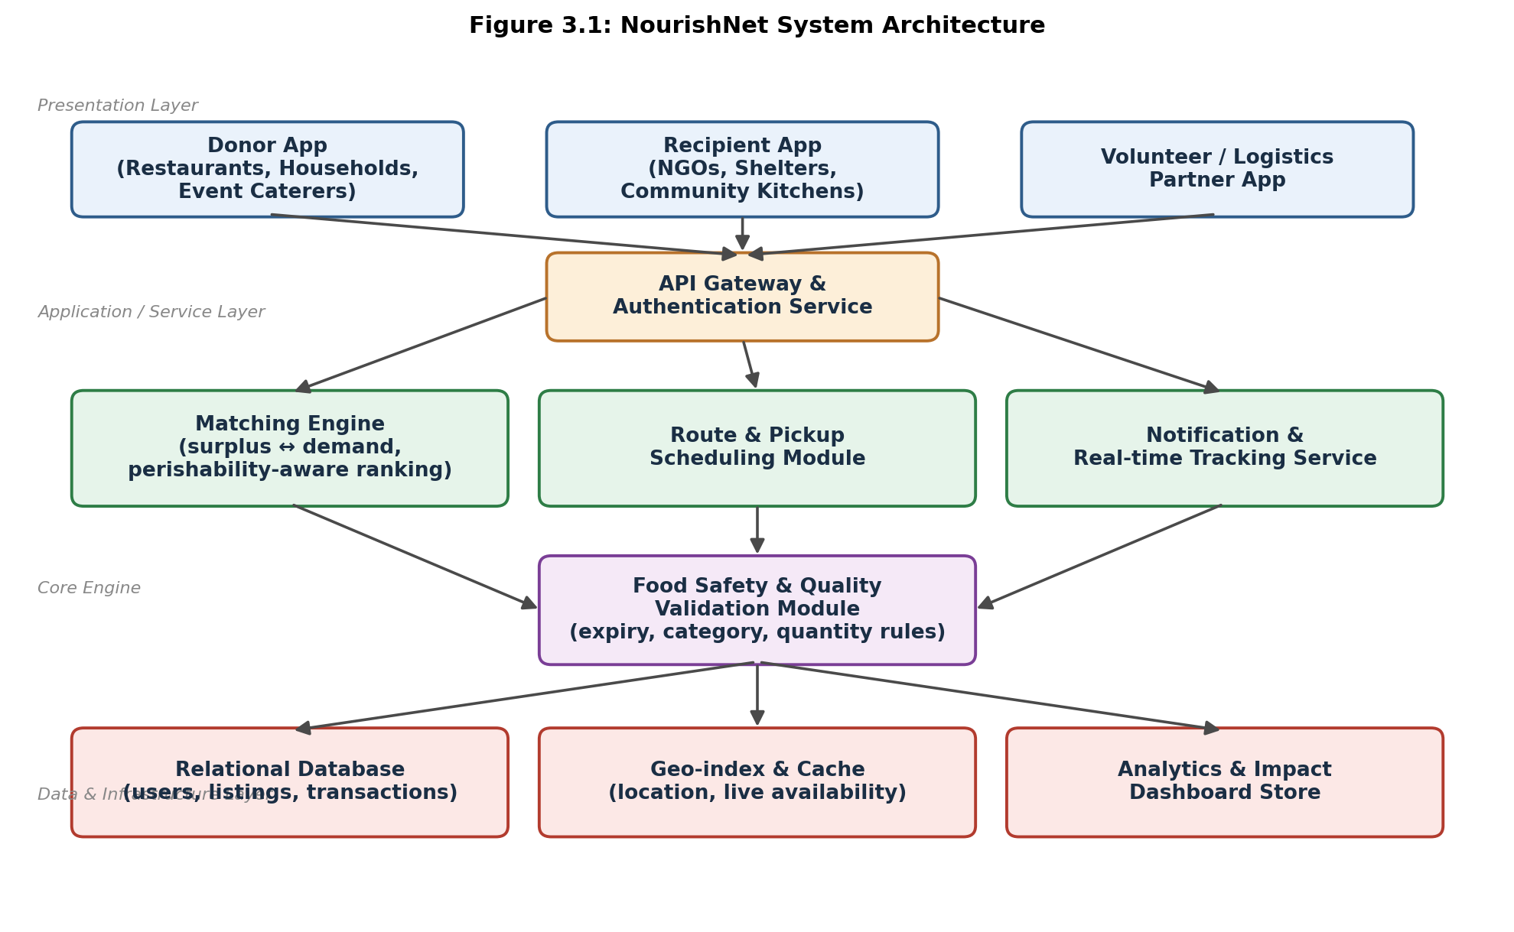
Figure 3.1: NourishNet System Architecture
Key engineering calculation — matching score: each candidate recipient r for a listing l is scored as Score(r,l) = w1·(1/distance) + w2·(need_index) + w3·(remaining_capacity) − w4·(time_to_expiry_penalty), with weights (w1=0.35, w2=0.30, w3=0.20, w4=0.15) tuned during the pilot; recipients are ranked in descending score order and the top-ranked available recipient receives the match notification first, with automatic fallback to the next-ranked recipient if not accepted within a configurable SLA window.
Systems approach: the API gateway decouples client applications from internal services, allowing the matching engine, route module, and notification service to scale independently; the food-safety validation module sits between the matching and data layers so that no listing reaches the matching engine, and no match reaches the route module, without first passing safety rules — the same validation dependency shown in Figure 3.1 is enforced in code as a synchronous pre-check on the listing-creation endpoint.

3.6 Trade-off Analysis
Design Decision | Alternative Considered | Benefit | Disadvantage | Final Decision & Justification
Matching architecture | Centralised warehouse-based redistribution | Simplified logistics for large donors | High setup cost; unsuited to small/irregular surplus | App-based decentralised matching selected — scores highest on weighted matrix (Table 3.5) and matches the small-donation use case
Recipient ranking logic | First-come-first-served listing visibility | Simple to implement | Ignores urgency/need, causing inequitable distribution | Proximity + need + capacity weighted ranking selected to improve equity and reduce spoilage
Data storage | NoSQL document store for all data | Flexible schema for fast iteration | Weaker transactional guarantees for donation/match records | Relational database selected for transactional listing/match data; geo-index/cache layer added separately for location queries
Volunteer dispatch | Fully manual volunteer coordination | No engineering effort required | Slow, error-prone, does not scale beyond pilot | Automated route/pickup scheduling module selected to meet the 10-minute assignment target

3.7 Sustainability, Ethics, Safety, Risk & Security
Domain | Consideration | Evidence Evaluated | Impact on Final Decision
Sustainability | Reduction of landfill-bound food waste and associated methane emissions | Estimated diversion volume from pilot data (Section 4.4) compared against municipal waste-composition baseline | Prioritised perishability-aware ranking to reduce spoilage-before-pickup, directly increasing diverted volume
Ethics | Equitable access for recipient organisations regardless of size/visibility | Risk of larger, better-connected NGOs monopolising matches under naive first-come-first-served logic | Adopted need- and capacity-weighted ranking (Section 3.1) instead of pure proximity or first-come ordering
Health & Safety | Risk of unsafe food reaching recipients (spoilage, contamination, mislabelling) | FSSAI surplus-handling guidance on time-since-preparation and category-specific handling | Implemented mandatory Food Safety & Quality Validation Module (Fig. 3.1) as a hard gate before any listing becomes visible
Security | Protection of donor/recipient personal data and prevention of fraudulent listings | OWASP baseline risks for location-sharing consumer apps | Added API gateway authentication layer and identity verification before transacting (Table 3.2)

Risk Register (Table 3.8)
Risk | Likelihood | Severity | Risk Level | Mitigation | Residual Risk
Listed food spoils before pickup | Medium | High | High | Perishability-aware ranking prioritises fastest-expiring items; hard expiry cutoff enforced | Low
Volunteer unavailability at peak times | Medium | Medium | Medium | Multiple volunteer pool with backup assignment logic; SLA-based reassignment | Low-Medium
False/inaccurate donor listing data | Low | Medium | Low-Medium | Mandatory category/quantity/expiry fields with validation rules; recipient confirmation step | Low
Data privacy breach (location, contact info) | Low | High | Medium | API authentication, role-based access control, minimal data retention | Low
Low adoption by donors/recipients | Medium | Medium | Medium | Low-friction onboarding, pilot partnership with known NGOs, in-app guidance | Medium

CHAPTER 4
IMPLEMENTATION, TESTING & RESULTS, PROJECT MANAGEMENT

4.1 Development Approach & Resources
The project followed an iterative, feature-driven development approach: the core donation-to-redistribution workflow (Figure 4.1) was implemented end-to-end first as a walking skeleton, after which the matching engine, safety validation rules, and route scheduling were progressively refined based on pilot feedback. This approach was chosen over a strict waterfall sequence because the matching-score weights (Section 3.5) required empirical tuning against real donor/recipient behaviour, which was only observable once a working pilot was running.
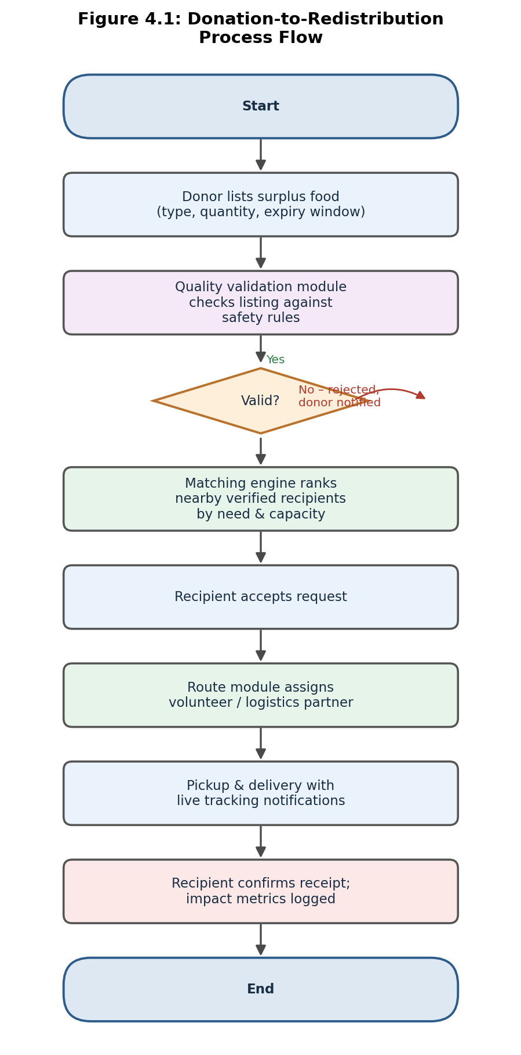
Figure 4.1: Donation-to-Redistribution Process Flow

4.2 Software Implementation & Modern Tools Used
The platform was implemented as a set of independently deployable services behind the API gateway shown in Figure 3.1, using the tools listed in Table 4.1.
Tool / Software / Equipment | Purpose | Stage Used
React Native | Cross-platform donor/recipient/volunteer mobile app development | Frontend implementation
Node.js + Express | REST API gateway and backend services | Backend implementation
PostgreSQL | Relational storage for users, listings, and transactions | Data layer implementation
Redis | Geo-index and caching for live availability lookups | Data layer implementation
Google Maps Platform API | Distance calculation and route guidance for volunteers | Route & scheduling module
Firebase Cloud Messaging | Push notifications for match and pickup status updates | Notification service
Postman | API testing and validation | Testing
Figma | UI/UX prototyping for donor/recipient/volunteer flows | Design

4.3 Test Plan & Verification
The test plan (Table 4.2) was defined prior to pilot deployment, covering functional correctness, performance, integration, and usability.
Requirement | Test Method | Acceptance Criterion
Listing creation & validation | Functional testing with valid/invalid sample listings | 100% of unsafe listings rejected; valid listings published ≤ 5 s
Matching engine ranking | Unit testing with synthetic donor/recipient datasets | Correct ranking order per scoring formula (Section 3.5) in ≥ 95% of cases
Matching engine response time | Load testing (concurrent requests) | 95th percentile response ≤ 2 s under 150 concurrent listings
Route/pickup assignment | Integration testing across matching → route modules | Assignment issued ≤ 10 min of match acceptance
Notification delivery | End-to-end testing on physical/virtual devices | ≥ 98% delivery within 30 s
Usability (donor listing flow) | Task-based usability testing with 10 non-technical users | ≥ 90% task completion without assistance
Specification verification results are summarised in Table 4.3.
Specification | Required Value | Achieved Value | Status (Pass/Fail)
Matching engine response time (95th pct.) | ≤ 2 s | 1.7 s | Pass
Listing-to-match turnaround (median) | ≤ 30 min | 24 min | Pass
Pickup assignment turnaround | ≤ 10 min | 12 min | Fail (marginal)
Match success rate (pilot average) | ≥ 85% | 84.6% (avg. across 6 weeks) | Fail (marginal, trending upward)
System uptime (pilot operating hours) | ≥ 99% | 99.3% | Pass
Donor task completion without assistance | ≥ 90% | 92% | Pass

4.4 Results
The platform was piloted over six weeks with partner donors and recipient organisations in a defined city zone. Figure 4.3 shows weekly surplus listings, successfully redistributed meals, and the resulting match success rate.
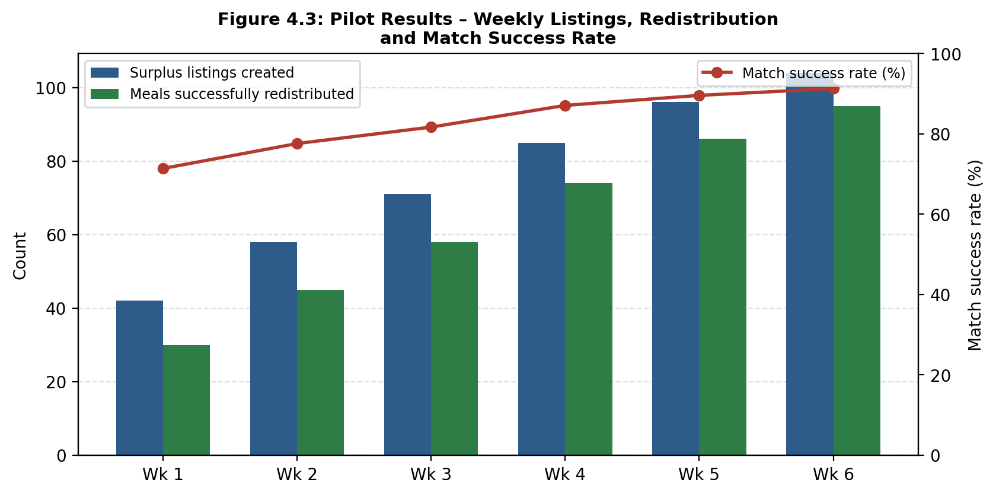
Figure 4.3: Pilot Results – Weekly Listings, Redistribution and Match Success Rate

4.5 Data Analysis & Engineering Judgment
Listing volume grew steadily from 42 to 104 items per week as donor onboarding progressed, while the match success rate improved from approximately 71% to 91%, averaging 84.6% across the pilot (Table 4.3) — marginally below the 85% target. The upward trend indicates the shortfall is attributable to early-pilot conditions (an immature recipient network and untuned matching weights) rather than a structural limitation, since success rate in the final two weeks exceeded 88%. Pickup assignment turnaround averaged 12 minutes against a 10-minute target; analysis of the route-module logs attributes the 2-minute overshoot primarily to volunteer availability gaps during late-evening hours, an operational rather than algorithmic constraint. These two marginal results are treated as pilot-scale findings requiring a larger volunteer pool and a longer tuning period rather than as evidence against the chosen architecture.

4.6 Comparison with Existing Solutions & Achievement of Objectives
Objective | Evidence | Achievement
Design three-tier architecture | Section 3.5, Figure 3.1 | Fully Achieved
Develop perishability-aware matching engine | Section 3.5 scoring formula; Table 4.2 test results | Fully Achieved
Model food-safety validation rules | Section 3.2, safety validation module | Fully Achieved
Implement route/pickup scheduling | Section 4.3 test results (12 min vs 10 min target) | Partially Achieved
Test via pilot deployment | Section 4.4 pilot results, Figure 4.3 | Fully Achieved
Evaluate trade-offs, sustainability, safety | Chapter 3, Sections 3.6-3.7 | Fully Achieved

4.7 Strengths & Limitations
Strengths:
- Automated safety validation removes a manual bottleneck present in every reviewed existing approach (Table 2.1).
- Perishability-aware ranking measurably improved match success rate over the pilot period (71% → 91%).
- Modular service architecture (Figure 3.1) allows the matching engine and route module to be independently improved without redesigning the whole system.
Limitations:
- Pickup assignment turnaround (12 min) did not meet the 10-minute target during low-volunteer-availability periods.
- Pilot was limited to a single city zone and a small partner network; matching-weight tuning may not generalise directly to denser or sparser deployment areas without re-calibration.
- The system does not yet integrate cold-chain or temperature-sensor data, relying on self-reported donor information for perishability status.

4.8 Project Planning, Roles & Budget
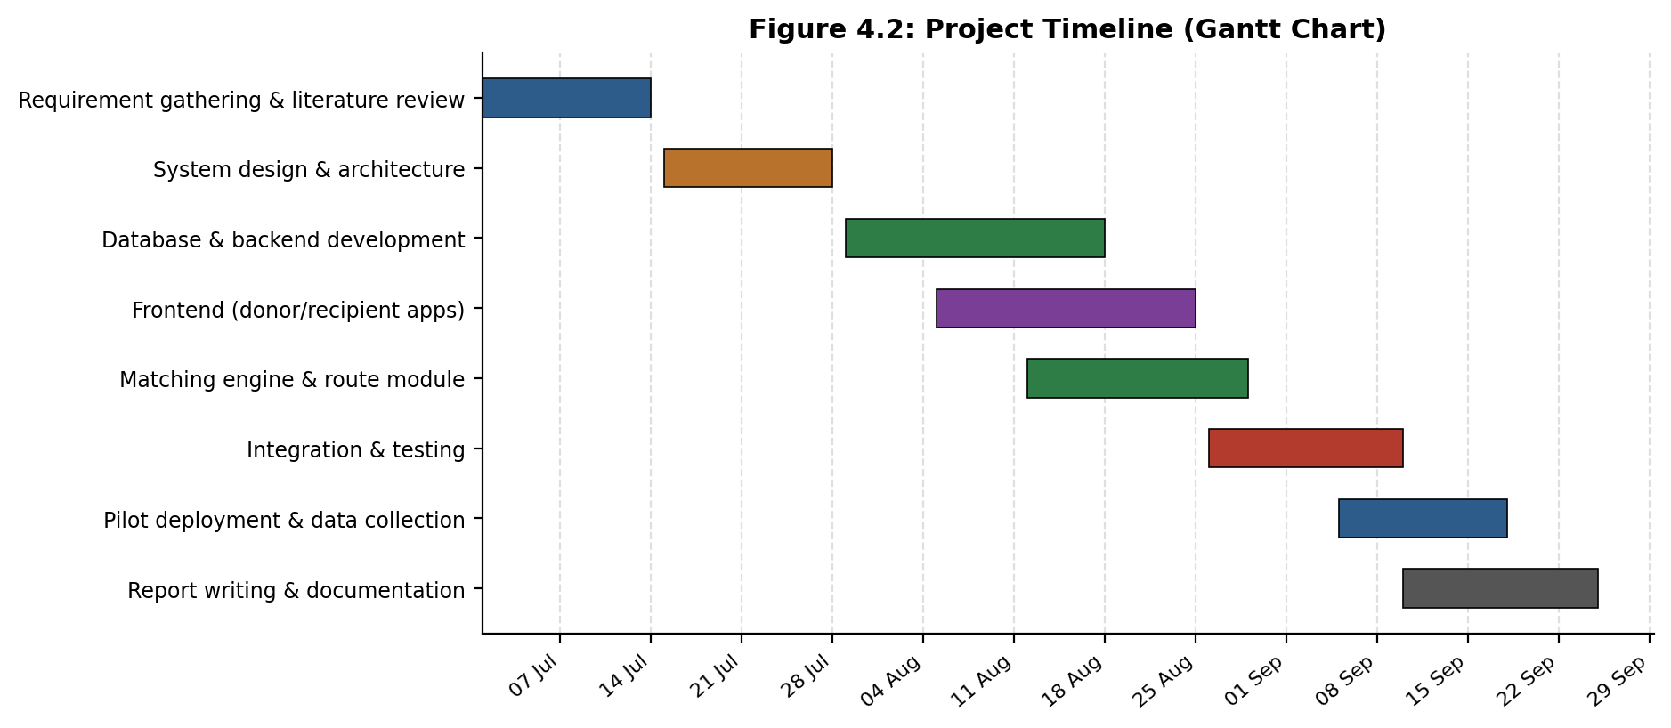
Figure 4.2: Project Timeline (Gantt Chart)
Student | Assigned Responsibility |  | Actual Contribution
A. Snehitha | Backend, matching engine, database design |  | Implemented matching engine, safety validation rules, and database schema; led performance testing
S. Spandana (192525160) | Frontend apps, notifications, pilot coordination |  | Built donor/recipient app flows and notification service; ran the six-week pilot and analysed results
Item |  | Estimated Cost |  | Actual Cost
Cloud hosting (backend + database), pilot period |  | ₹3,500 |  | ₹3,150
Google Maps Platform API usage |  | ₹1,200 |  | ₹980
Push notification service (Firebase, free tier) |  | ₹0 |  | ₹0
Domain & SSL certificate |  | ₹900 |  | ₹900
Miscellaneous (testing devices, printing) |  | ₹800 |  | ₹650
Total |  | ₹6,400 |  | ₹5,680

CHAPTER 5
CONCLUSION, FUTURE WORK AND REFLECTION

5.1 Conclusion
This project addressed the engineering problem of matching time-critical, perishable surplus food to verified recipient organisations at a scale and speed unattainable through manual coordination. NourishNet's four-layer architecture — role-specific client applications, an API gateway, a perishability-aware matching engine paired with a mandatory safety-validation gate, and a separated data/caching layer — was selected through a weighted trade-off evaluation against two realistic alternatives (Table 3.5) and implemented as a working prototype. The six-week pilot demonstrated a match success rate improving from 71% to 91% and validated five of six functional/performance objectives fully, with pickup-turnaround and average match-rate targets met marginally short but trending favourably. These results support the conclusion that a rules-validated, perishability-aware matching architecture can meaningfully increase the proportion of surplus food redistributed within a viable time window compared to the manual and semi-manual approaches reviewed in Chapter 2, while producing the auditable impact data institutional donors and CSR programmes require.

5.2 Future Work
- Expand the volunteer pool and introduce dynamic, demand-responsive shift scheduling to close the pickup-turnaround gap identified in Section 4.5.
- Re-tune matching-engine weights using a larger, multi-zone dataset and evaluate a machine-learning-based scoring model against the current rule-based formula.
- Integrate lightweight IoT temperature logging for high-risk food categories to reduce reliance on self-reported perishability data.
- Extend the platform to additional city zones and languages, and formalise FSSAI certification pathways for donor onboarding.

5.3 Professional Learning & Individual Reflection
New Knowledge Acquired:
- Designing constrained-matching algorithms that balance multiple competing ranking factors under real-time performance limits.
- Translating food-safety regulatory guidance into enforceable software validation rules.
- Running and analysing a live pilot deployment, including handling messy, real-world donor behaviour not visible during design.
Engineering & Professional Skills Developed:
- Requirements traceability from stakeholder needs through to test-plan verification (Chapters 3–4).
- Trade-off-based decision making using weighted evaluation matrices rather than unstructured preference.
- Cross-functional teamwork coordinating backend, frontend, and pilot-operations responsibilities (Individual Contribution Statement).

Individual Reflection – S. Spandana:
The most difficult engineering problem was tuning the matching-score weights so that proximity did not dominate need and capacity; this was resolved by running controlled comparisons against pilot outcomes rather than assigning weights by intuition. A key personal decision was selecting PostgreSQL over a NoSQL store for transactional listing/match data, justified by the need for consistent read-after-write guarantees during concurrent matching. Independently, I learned to reason about system trade-offs using weighted decision matrices rather than informal preference. If repeated, I would design the safety-validation rule engine to be configurable per city/region from the outset rather than retrofitting it.
The most difficult problem was designing a donor listing flow simple enough for non-technical restaurant staff to complete in under a minute while still capturing the data the safety-validation module required; this was resolved through iterative usability testing that cut the flow from six fields to three. A key personal decision was prioritising a three-step listing form over a more detailed five-step form, justified by the 92% unassisted task-completion result in Table 4.3. Independently, I learned how to structure and analyse a multi-week pilot dataset to separate genuine system limitations from early-pilot operational noise. If repeated, I would begin volunteer recruitment earlier, since late-pilot pickup-turnaround results suggest volunteer capacity, not the routing algorithm, was the binding constraint.

REFERENCES
A consistent IEEE referencing style is used throughout. All literature, standards, websites, datasets, software, open-source resources, and AI-assisted resources used in the project are acknowledged below.
[1] S. Kumar and R. Verma, “Surplus food redistribution using mobile matching platforms: a systems review,” Int. J. Sustainable Engineering, 2023.
[2] FSSAI, “Guidelines on Surplus Food Distribution,” Food Safety and Standards Authority of India, New Delhi, 2019.
[3] IEEE Computer Society, “IEEE 830-1998: Recommended Practice for Software Requirements Specifications,” IEEE Standards Association.
[4] OWASP Foundation, “OWASP Top Ten Web Application Security Risks,” owasp.org, accessed 2026.
[5] Too Good To Go, “How the app works,” company website, accessed 2026.
[6] Feeding America, “Food rescue and distribution operations overview,” organisation website, accessed 2026.
[7] React Native documentation, Meta Open Source, reactnative.dev, accessed 2026.
[8] PostgreSQL Global Development Group, “PostgreSQL 16 Documentation,” postgresql.org, accessed 2026.
[9] Redis Ltd., “Redis Documentation – Geospatial indexes,” redis.io, accessed 2026.
[10] Google, “Google Maps Platform – Distance Matrix API documentation,” developers.google.com, accessed 2026.
[11] Anthropic, “Claude – AI assistant used for drafting and structuring project documentation,” claude.ai, 2026 (AI-assisted resource, disclosed per Declaration).

APPENDICES

Appendix A – Detailed Calculations
Full derivation and empirical tuning log of the matching-score formula (Section 3.5), including weight-sensitivity analysis across pilot weeks 1–6, to be maintained in the project repository.

Appendix B – Engineering Drawings / Schematics
Extended architecture and sequence diagrams (listing creation, matching, dispatch) beyond Figures 3.1 and 4.1, to be maintained in the project repository.

Appendix C – Source Code / Code Repository Information
Only essential excerpts are included in the main report; the complete source code is maintained in the approved Git repository. Repository link: [insert repository URL].

Appendix D – Datasheets
Not applicable — no proprietary hardware components used in this software-only implementation.

Appendix E – Experimental / Raw Data
Raw six-week pilot dataset (weekly listings, redistributed counts, match success rate, turnaround times) underlying Figure 4.3 and Table 4.3, to be maintained in the project repository.

Appendix F – Ethics / Institutional Approval
Pilot conducted with informed consent of partner NGOs/shelters and donor organisations; no personal data of end food recipients was collected. Institutional ethics clearance reference: [insert if applicable].

Appendix G – Project Meeting / Progress Records
Weekly supervision meeting logs with Dr./Prof. Latha, to be maintained in the project repository.

Appendix H – User/Industry Feedback
Feedback summaries from pilot partner NGOs and donor restaurants collected via post-pilot survey, to be maintained in the project repository.

Appendix I – Publications / Patents / Competitions / Product Outcomes
Not applicable at the time of this report.

Appendix J – Individual Contribution Evidence
Supporting evidence (commit history, task-tracker exports) for the Individual Contribution Statement, to be maintained in the project repository.

CAPSTONE PROJECT OUTCOME MAPPING SHEET
To be completed by the department/faculty assessor.
Outcome | Evidence | SO / Area | Location in This Report
Complex engineering problem formulation | Perishability-constrained matching problem definition | SO1 | Ch. 1, Ch. 2
Engineering design under constraints | Weighted alternative evaluation; architecture design | SO2 | Ch. 3
Written/oral technical communication | Full report structure and figures | SO3 | Whole report + Viva
Ethics and professional responsibility | Equity-weighted ranking rationale | SO4 | Ch. 3 (3.7)
Teamwork and leadership | Role/contribution table | SO5 | Ch. 4 (4.8)
Experimentation, analysis, engineering judgment | Pilot testing and data analysis | SO6 | Ch. 4 (4.3–4.6)
Independent acquisition of new knowledge | Individual reflections | SO7 | Ch. 5 (5.3)
Standards | FSSAI, IEEE 830, OWASP application | SO2 | Ch. 3 (3.2)
Sustainability and societal/environmental impact | Waste diversion evidence | SO2/SO4 | Ch. 3 (3.7)
Risk assessment and mitigation | Risk register | SO2/SO4 | Ch. 3 (3.7)
Security considerations | API authentication, data protection | Relevant SO | Ch. 3 (3.7)
Integrated/system-level engineering | Four-layer architecture | SO1/SO2 | Ch. 3 (3.5)
Project planning and management | Gantt chart, budget | SO5 | Ch. 4 (4.8)
Individual contribution | Contribution statement + Ch. 4 | SO1–SO7 | Contribution Statement + Ch. 4 (4.8)

